# Week 3: Spring Data JPA With Spring Boot and Hibernate

# 1.Spring Data JPA - Quick Example HandsOn

## 1. Country.java

package com.cognizant.orm_learn.model;  
  
import jakarta.persistence.Column;  
import jakarta.persistence.Entity;  
import jakarta.persistence.Id;  
import jakarta.persistence.Table;  
  
@Entity  
@Table(name = "country")  
public class Country {  
  
 @Id  
 @Column(name = "co_code")   
 private String code;  
  
 @Column(name = "co_name")   
 private String name;  
  
 public String getCode() {  
 return code;  
 }  
  
 public void setCode(String code) {  
 this.code = code;  
 }  
  
 public String getName() {  
 return name;  
 }  
  
 public void setName(String name) {  
 this.name = name;  
 }  
  
 @Override  
 public String toString() {  
 return "Country [code=" + code + ", name=" + name + "]";  
 }  
}

## 2. CountryRepository.java

package com.cognizant.orm_learn.repository;  
  
import org.springframework.data.jpa.repository.JpaRepository;  
import org.springframework.stereotype.Repository;  
  
import com.cognizant.orm_learn.model.Country;  
  
@Repository  
public interface CountryRepository extends JpaRepository<Country, String> {  
  
}

## 3. CountryService.java

package com.cognizant.orm_learn.service;  
  
import java.util.List;  
  
import org.springframework.beans.factory.annotation.Autowired;  
import org.springframework.stereotype.Service;  
import org.springframework.transaction.annotation.Transactional;  
  
import com.cognizant.orm_learn.model.Country;  
import com.cognizant.orm_learn.repository.CountryRepository;  
  
@Service  
public class CountryService {  
  
 @Autowired  
 private CountryRepository countryRepository;  
  
 @Transactional  
 public List<Country> getAllCountries() {  
 return countryRepository.findAll();  
 }  
}

## 4. application.properties

spring.application.name=orm-learn  
# Logging  
logging.level.org.springframework=info  
logging.level.com.cognizant=debug  
logging.level.org.hibernate.SQL=trace  
logging.level.org.hibernate.type.descriptor.sql=trace  
  
# Console log pattern  
logging.pattern.console=%d{dd-MM-yy} %d{HH:mm:ss.SSS} %-20.20thread %5p %-25.25logger{25} %25M %4L %m%n  
  
# Database connection  
spring.datasource.driver-class-name=com.mysql.cj.jdbc.Driver  
spring.datasource.url=jdbc:mysql://localhost:3306/ormlearn  
spring.datasource.username=root  
spring.datasource.password=admin  
  
# Hibernate  
spring.jpa.hibernate.ddl-auto=validate  
spring.jpa.properties.hibernate.dialect=org.hibernate.dialect.MySQL5Dial ect

## 5. OrmLearnApplication.java

package com.cognizant.orm_learn;  
  
import java.util.List;  
  
import org.slf4j.Logger;  
import org.slf4j.LoggerFactory;  
  
import org.springframework.boot.SpringApplication;  
import org.springframework.boot.autoconfigure.SpringBootApplication;  
import org.springframework.context.ApplicationContext;  
  
import com.cognizant.orm_learn.model.Country;  
import com.cognizant.orm_learn.service.CountryService;  
  
@SpringBootApplication  
public class OrmLearnApplication {  
  
 private static final Logger *LOGGER* = LoggerFactory.*getLogger*(OrmLearnApplication.class);  
 private static CountryService *countryService*;  
  
 public static void main(String[] args) {  
 ApplicationContext context = SpringApplication.*run*(OrmLearnApplication.class, args);  
 *countryService* = context.getBean(CountryService.class);  
  
 *testGetAllCountries*();  
 }  
  
 private static void testGetAllCountries() {  
 *LOGGER*.info("Start");  
  
 List<Country> countries = *countryService*.getAllCountries();  
 *LOGGER*.debug("countries={}", countries);  
  
 *LOGGER*.info("End");  
 }  
}

## 6. Screenshots

- Console Output showing data retrieval (country list)

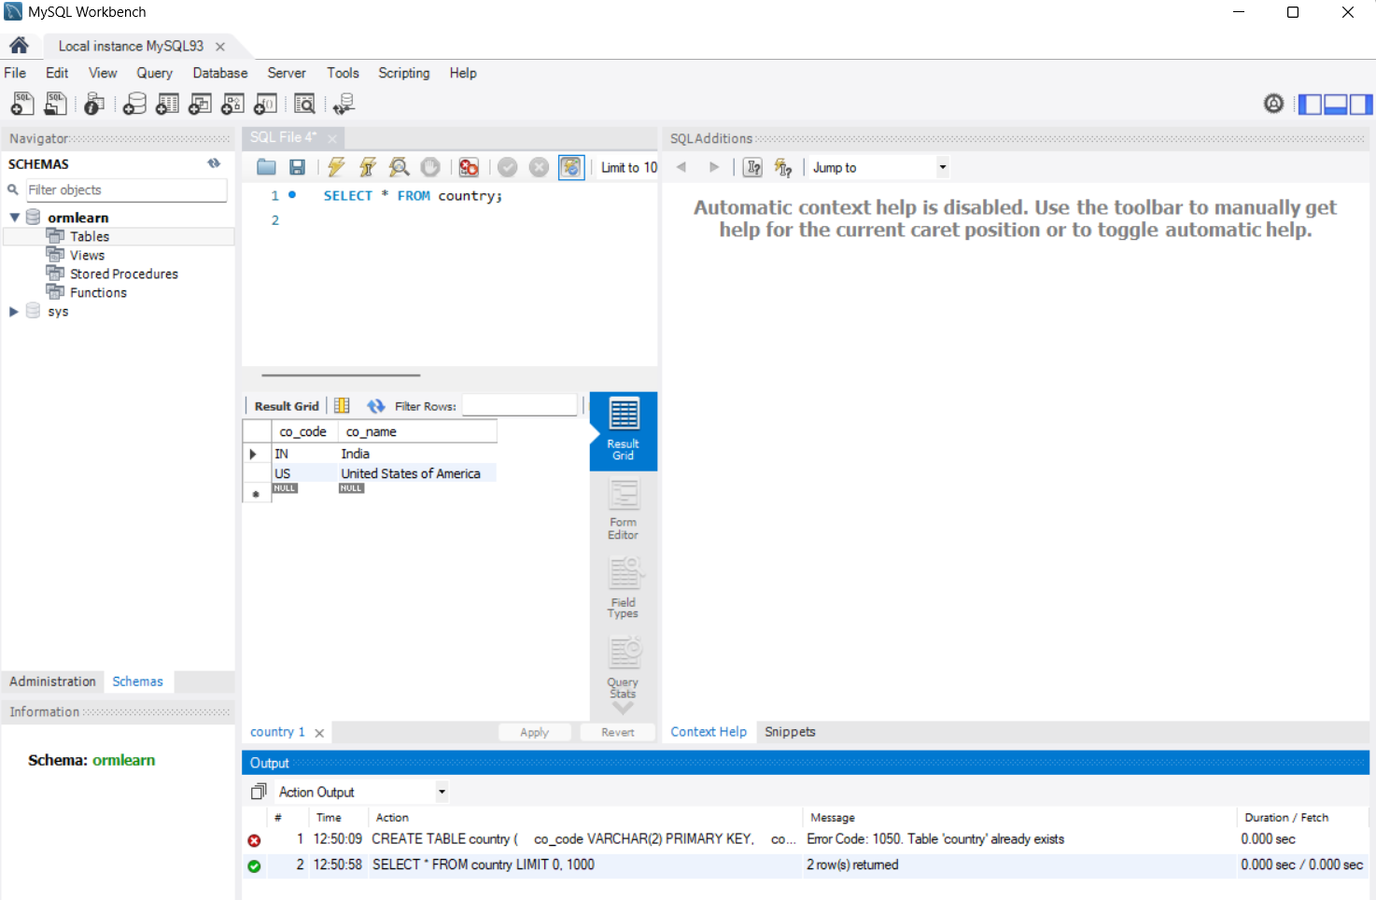

- MySQL Workbench screenshot showing the `country` table and its contents.